**Heat Distribution Systems**

Radiators are used in steam and hot water heating. | Photo courtesy of ©iStockphoto/Jot

Heat is distributed through your home in a variety of ways. Forced-air systems use ducts that can also be used for central air conditioning and heat pump systems. Radiant heating systems also have unique heat distribution systems. That leaves two heat distribution systems -- steam radiators and hot water radiators.

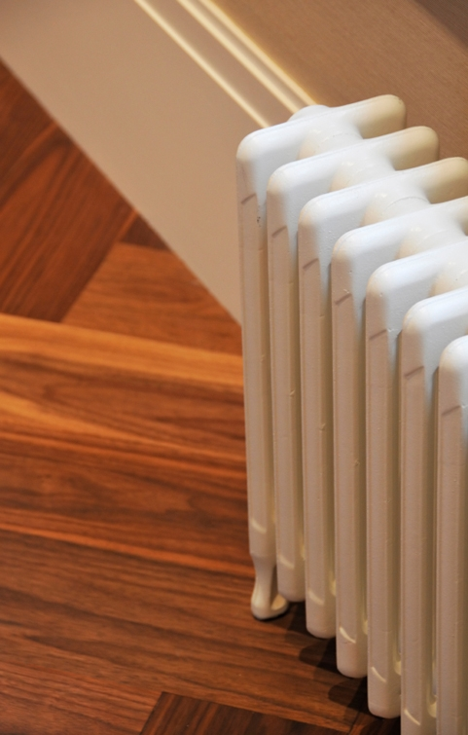

Steam Radiators

Steam heating is one of the oldest heating technologies, but the process of boiling and condensing water is inherently less efficient than more modern systems, plus it typically suffers from significant lag times between the boiler turning on and the heat arriving in the radiators. As a result, steam systems make it difficult to implement control strategies such as a night setback system.

The first central heating systems for buildings used steam distribution because steam moves itself through piping without the use of pumps. Non-insulated steam pipes often deliver unwanted heat to unfinished areas, making fiberglass pipe insulation -- which can withstand high temperatures—very cost-effective.

Regular maintenance for steam radiators depends on whether the radiator is a one-pipe system (the pipe that supplies steam also returns condensate) or a two-pipe system (a separate pipe returns condensate). One-pipe systems use automatic air vents on each radiator, which bleed air as steam fills the system and then shut automatically when steam reaches the vent. A clogged air vent will keep a steam radiator from heating up. An air vent stuck open allows steam to continually escape to the living space, raising relative humidity and wasting fuel. Air vents can sometimes be cleaned by boiling them in a water and vinegar solution, but usually need to be replaced.

Steam radiators can also warp the floor they are sitting on and their thermal expansion and contraction over time can dig ruts into the floor. Both of these effects can cause the radiator to tilt, preventing water from properly draining from the radiator when it cools. This will cause banging noises when the radiator is heating up. Shims should be inserted under radiators to pitch them slightly toward the pipe in a one-pipe system or toward the steam trap in a two-pipe system.

In two-pipe systems, older steam traps often stick in either the open or closed position, throwing off the balance in the system. If you seem to have problems with some radiators providing too much heat and others providing too little, this might be the cause. The best approach is often to simply replace all the steam traps in the system.

Steam radiators located on exterior walls can cause heat loss by radiating heat through the wall to the outdoors. To prevent such heat loss, you can install heat reflectors behind these radiators. You can make your own reflector from foil-covered cardboard, available from many building supply stores, or by mounting foil onto a foam board or other similar insulating surface. The foil should face away from the wall, and the reflector should be the same size or slightly larger than the radiator. Periodically clean the reflectors to maintain maximum heat reflection.

Hot Water Radiators

Hot-water radiators are one of the most common heat distribution systems in newer homes, second only to forced-air systems. They are typically a baseboard-type radiator or an upright design that resembles steam radiators. The most common problem in hot-water systems is unwanted air in the system. At the start of each heating season, while the system is running, go from radiator to radiator and open each bleed valve slightly, then close it when water starts to escape through the valve. For multi-level homes, start at the top floor and work your way down.

One way to save energy in hot-water systems is to retrofit them to provide separate zone control for different areas of large homes. Zone control is most effective when large areas of the home are not used often or are used on a different schedule than other parts of the home. A heating professional can install automatic valves on the hot-water radiators, controlled by thermostats in each zone of the house. Using programmable thermostats will allow you to automatically heat and cool off portions of your home to match your usage patterns.

Zone control works best in homes designed to operate in different heating zones, with each zone insulated from the others. In homes not designed for zone control, leaving one section at a lower temperature could cause comfort problems in adjacent rooms because they will lose heat to the cooler parts of the home. Zone control will also work best when the cooler sections of the home can be isolated from the others by closing doors. In some cases, new doors may be needed to isolate one area from another. Cooler parts of the home should be kept around 50°F to prevent water pipes from freezing. Never shut off heat entirely in an unused part of your home.

From：https://www.energy.gov/energysaver/home-heating-systems/heat-distribution-systems